Week 5 Penetration Testing Report

Introduction

This report document hereby describes the proceedings and results of a Black Box security assessment conducted against the Week 5 Labs. The report hereby lists the findings and corresponding best practice mitigation actions and recommendations.

1. Objective

The objective of the assessment was to uncover vulnerabilities in the Week 5 Labs and provide a final security assessment report comprising vulnerabilities, remediation strategy and recommendation guidelines to help mitigate the identified vulnerabilities and risks during the activity.

2. Scope

This section defines the scope and boundaries of the project.
Application Name | {Cross-Origin Resource Sharing Labs}

3. Summary

Outlined is a Black Box Application Security assessment for the Week 5 Labs.

Total number of Sub-labs: 7 Sub-labs

High | Medium | Low
3 | 2 | 2

High - Number of Sub-labs with hard difficulty level
Medium - Number of Sub-labs with Medium difficulty level
Low - Number of Sub-labs with Easy difficulty level

1. {Cross-Origin Resource Sharing Labs}

1.1. {CORS with Arbitrary Origin}

Reference | Risk Rating
CORS with Arbitrary Origin | Low
Tools Used
Google Chrome Browser, CORS tool, Burp Suite
Vulnerability Description
I found this vulnerability by intercepting a login request into burp suite and adding origin header to the interception and forwarding it and successfully getting expected output.
How It Was Discovered
Manual Analysis
Vulnerable URLs
https://www.bugbountyhunter.org/internship_labs/HTML/cors_lab/lab_1/login.php
Consequences of not Fixing the Issue
Attackers would treat many victims to visit the attacker's website, if the victim is logged in, then his personal information is recorded in the attacker's server. Attackers can perform any action in the user's account, by bypassing CSRF tokens.
Suggested Countermeasures
Only Allow trusted sites.
References
https://portswigger.net/web-security/cors

Proof of Concept

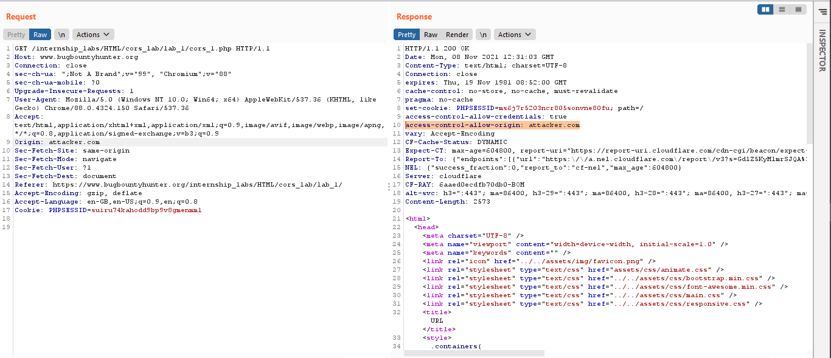

1.2. { CORS with null origin}

Reference | Risk Rating
CORS with null origin | Low
Tools Used
Google Chrome Browser, CORS tool, Burp Suite
Vulnerability Description
I found this vulnerability by intercepting a login request into burp suite and adding origin header to the interception and forwarding it and successfully getting expected output.
How It Was Discovered
Manual Analysis
Vulnerable URLs
https://www.bugbountyhunter.org/internship_labs/HTML/cors_lab/lab_2/login.php
Consequences of not Fixing the Issue
Attackers would treat many victims to visit the attacker's website, if the victim is logged in, then his personal information is recorded in the attacker's server. Attackers can perform any action in the user's account, by bypassing CSRF tokens.
Suggested Countermeasures
Avoid whitelisting null.
References
https://owasp.org/www-community/attacks/CORS_OriginHeaderScrutiny

Proof of Concept
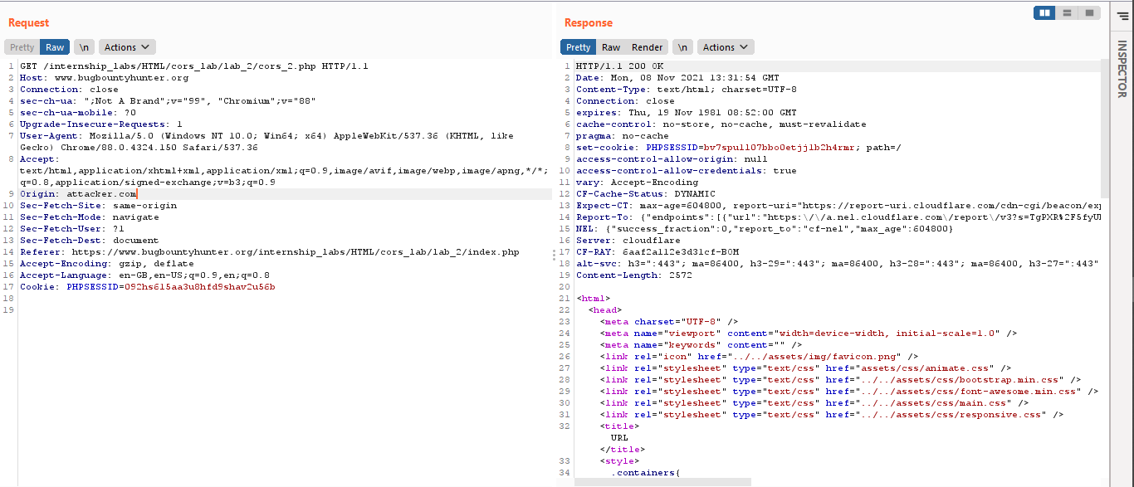

1.3. { CORS with Prefix Match}

Reference | Risk Rating
CORS with Prefix Match | Medium
Tools Used
Google Chrome Browser, CORS tool, Burp Suite
Vulnerability Description
I found this vulnerability by intercepting a login request into burp suite and adding origin header to the interception and forwarding it and successfully getting expected output.
How It Was Discovered
Manual Analysis
Vulnerable URLs
https://www.bugbountyhunter.org/internship_labs/HTML/cors_lab/lab_3/cors_3.php
Consequences of not Fixing the Issue
Attackers would treat many victims to visit the attacker's website, if the victim is logged in, then his personal information is recorded in the attacker's server. Attackers can perform any action in the user's account, by bypassing CSRF tokens.
Suggested Countermeasures
Proper configuration of cross-domains requests.
References
https://portswigger.net/web-security/cors

Proof of Concept
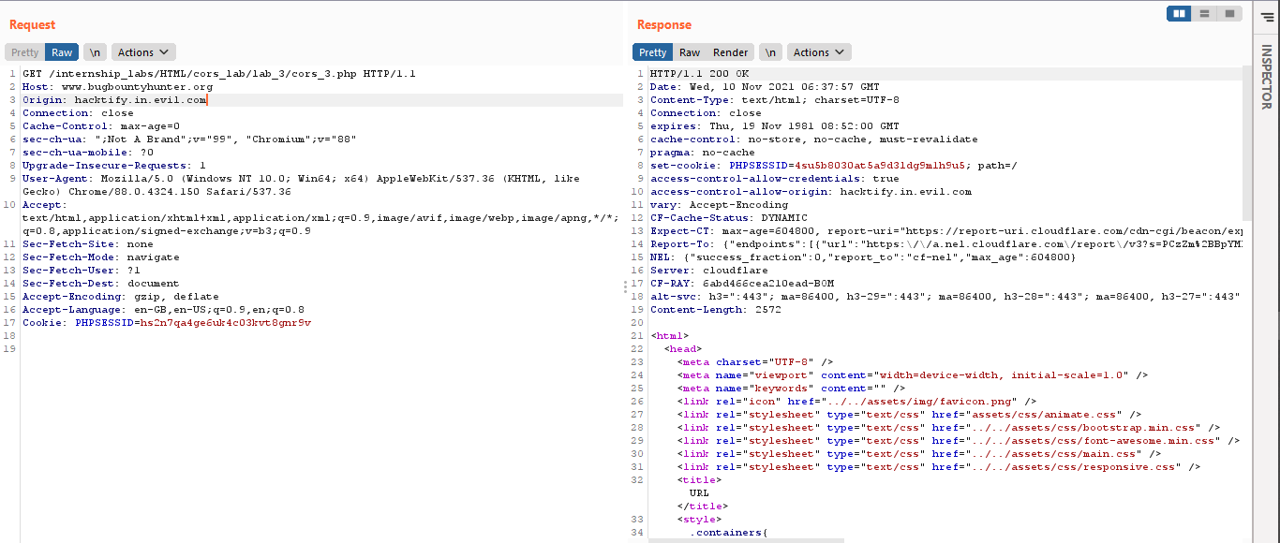

1.4. { CORS with Suffix Match}

Reference | Risk Rating
CORS with Suffix Match | Medium
Tools Used
Google Chrome Browser, CORS tool, Burp Suite
Vulnerability Description
I found this vulnerability by intercepting a login request into burp suite and adding origin header to the interception and forwarding it and successfully getting expected output.
How It Was Discovered
Manual Analysis
Vulnerable URLs
https://www.bugbountyhunter.org/internship_labs/HTML/cors_lab/lab_4/cors_4.php
Consequences of not Fixing the Issue
Attackers would treat many victims to visit the attacker's website, if the victim is logged in, then his personal information is recorded in the attacker's server. Attackers can perform any action in the user's account, by bypassing CSRF tokens.
Suggested Countermeasures
Only Allow trusted sites.
References
https://owasp.org/www-community/attacks/CORS_OriginHeaderScrutiny

Proof of Concept
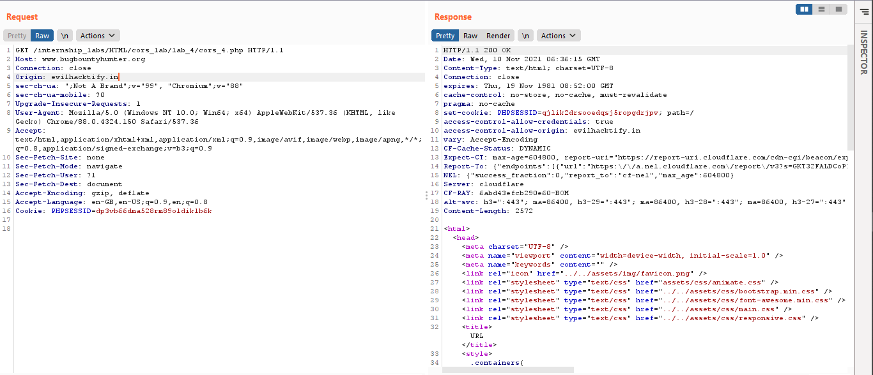

1.5. { CORS with Escape Dot}

Reference | Risk Rating
CORS with Escape Dot | Hard
Tools Used
Google Chrome Browser, CORS tool, Burp Suite
Vulnerability Description
I found this vulnerability by intercepting a login request into burp suite and adding origin header to the interception and forwarding it and successfully getting expected output.
How It Was Discovered
Manual Analysis
Vulnerable URLs
https://www.bugbountyhunter.org/internship_labs/HTML/cors_lab/lab_5/cors_5.php
Consequences of not Fixing the Issue
Attackers would treat many victims to visit the attacker's website, if the victim is logged in, then his personal information is recorded in the attacker's server. Attackers can perform any action in the user's account, by bypassing CSRF tokens.
Suggested Countermeasures
Avoid wildcards in internal networks.
References
https://portswigger.net/web-security/cors

Proof of Concept
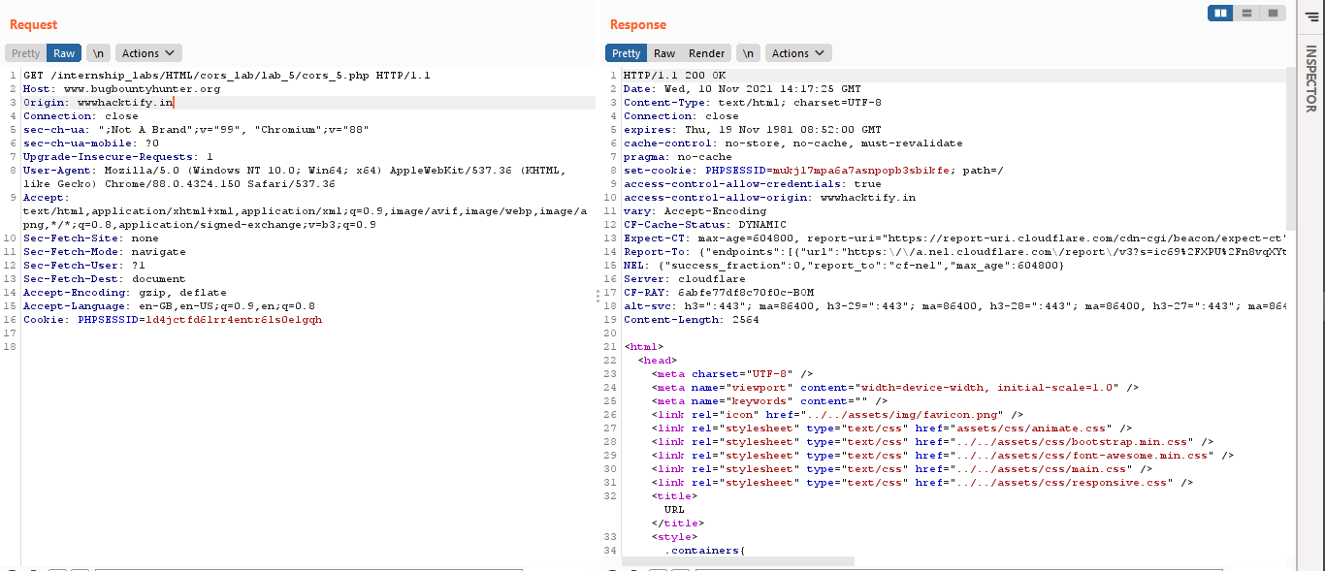

1.6. { CORS with Substring Match}

Reference | Risk Rating
CORS with Substring Match | Hard
Tools Used
Google Chrome Browser, CORS tool, Burp Suite
Vulnerability Description
I found this vulnerability by intercepting a login request into burp suite and adding origin header to the interception and forwarding it and successfully getting expected output.
How It Was Discovered
Manual Analysis
Vulnerable URLs
https://www.bugbountyhunter.org/internship_labs/HTML/cors_lab/lab_6/cors_6.php
Consequences of not Fixing the Issue
Attackers would treat many victims to visit the attacker's website, if the victim is logged in, then his personal information is recorded in the attacker's server. Attackers can perform any action in the user's account, by bypassing CSRF tokens.
Suggested Countermeasures
Proper configuration of cross-domains requests.
References
https://owasp.org/www-community/attacks/CORS_OriginHeaderScrutiny

Proof of Concept
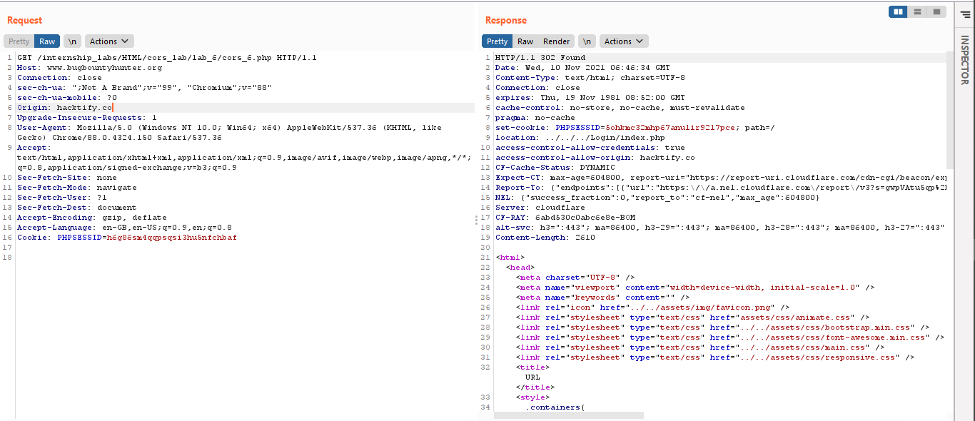

1.7. { CORS with Arbitrary Subdomain}

Reference | Risk Rating
CORS with Arbitrary Subdomain | Hard
Tools Used
Google Chrome Browser, CORS tool, Burp Suite
Vulnerability Description
I found this vulnerability by intercepting a login request into burp suite and adding origin header to the interception and forwarding it and successfully getting expected output.
How It Was Discovered
Manual Analysis
Vulnerable URLs
https://www.bugbountyhunter.org/internship_labs/HTML/cors_lab/lab_7/login.php
Consequences of not Fixing the Issue
Attackers would treat many victims to visit the attacker's website, if the victim is logged in, then his personal information is recorded in the attacker's server. Attackers can perform any action in the user's account, by bypassing CSRF tokens.
Suggested Countermeasures
Avoid wildcards in internal networks.
References
https://developer.mozilla.org/en-US/docs/Web/HTTP/CORS

Proof of Concept
